**Joe Wurts – Presented FAI Air Sport Medal - Flying NZ Awards Dinner**

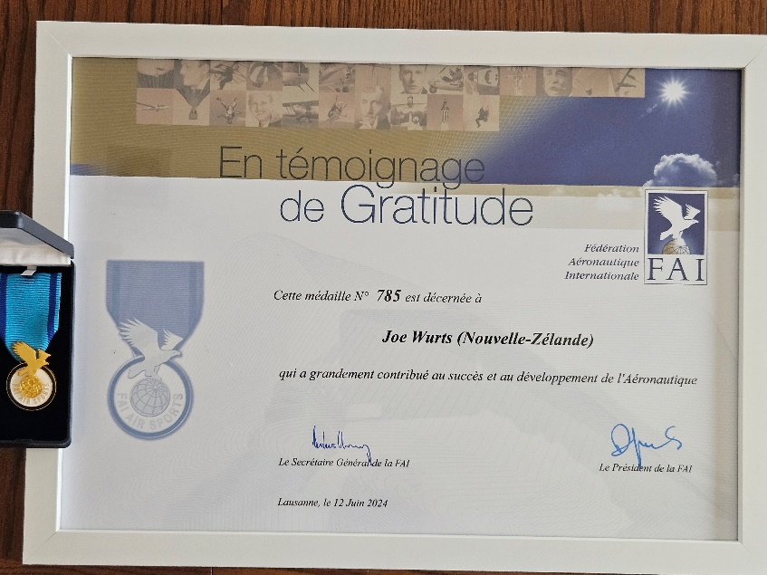

*History*. The FAI Air Sport Medal was established by FAI Council in 1991, the 100th anniversary of Lilienthal's first flights.

*Eligibility*. The Medal may be awarded to individuals or groups for outstanding services in connection with air sport activities, e.g. for work in FAI Commissions, for organising World and Continental Championships, **for training and educating new pilots, parachutists or aero modellers, and for promoting aviation in general, especially with regard to young.**

Joe Wurts is a lifelong model aircraft designer and talented Radio-Controlled Soaring Pilot.  He achievements are many with both world championship model designs and flying victories to his name.

 Joe has also run many seminars around the world explaining the soaring dynamics and understanding technology.  He has spent a huge amount of time helping people with their flying and modelling performance. He dedicates lots of patience and help to both younger and older people with experienced details on techniques and information.

  Since coming to New Zealand in 2004 Joe has led a dramatic improvement in the skills of New Zealand R/C Soaring Pilots which has contributed to many podium finishes at successive world championship events.

 Joe has been heavily involved in the NZ competition structure and the running of many soaring meetings including organization and scoring.

 Joe has also been involved with FAI and the CIAM and offering his expertise based on experience and knowledge.

